

Children Missing in Education

Policy

St. Bernadette’s Catholic Primary School

Approved by BoD: 26 March 2026
Policy Review Date: 26 March 2029

Statement of Intent
All children are entitled to a full-time education, regardless of their circumstances. Unfortunately, children missing education (CME) risk underachieving, being victims of abuse, and not being in education, employment or training (NEET) in later life.
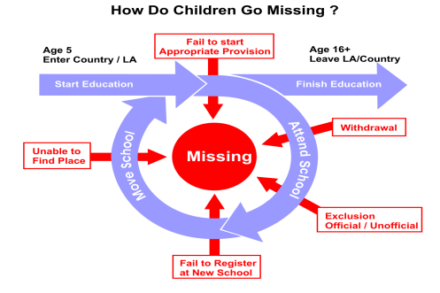

Definition of Children Missing Education
Those who are regularly absent or have missed 10 school days or more without permission may be at risk of becoming 'children missing education'.
What we do when a Child has been off for 10 or more days without explanation
We would submit a Child Missing from Education (CME) referral form and send it to Walsall Council.

The Local Authority (LA) then has a legal duty to identify when there are CME and help them back into education.
This Policy highlights what St. Bernadette’s Catholic Primary School will do to help the Local Authority with its duty.



