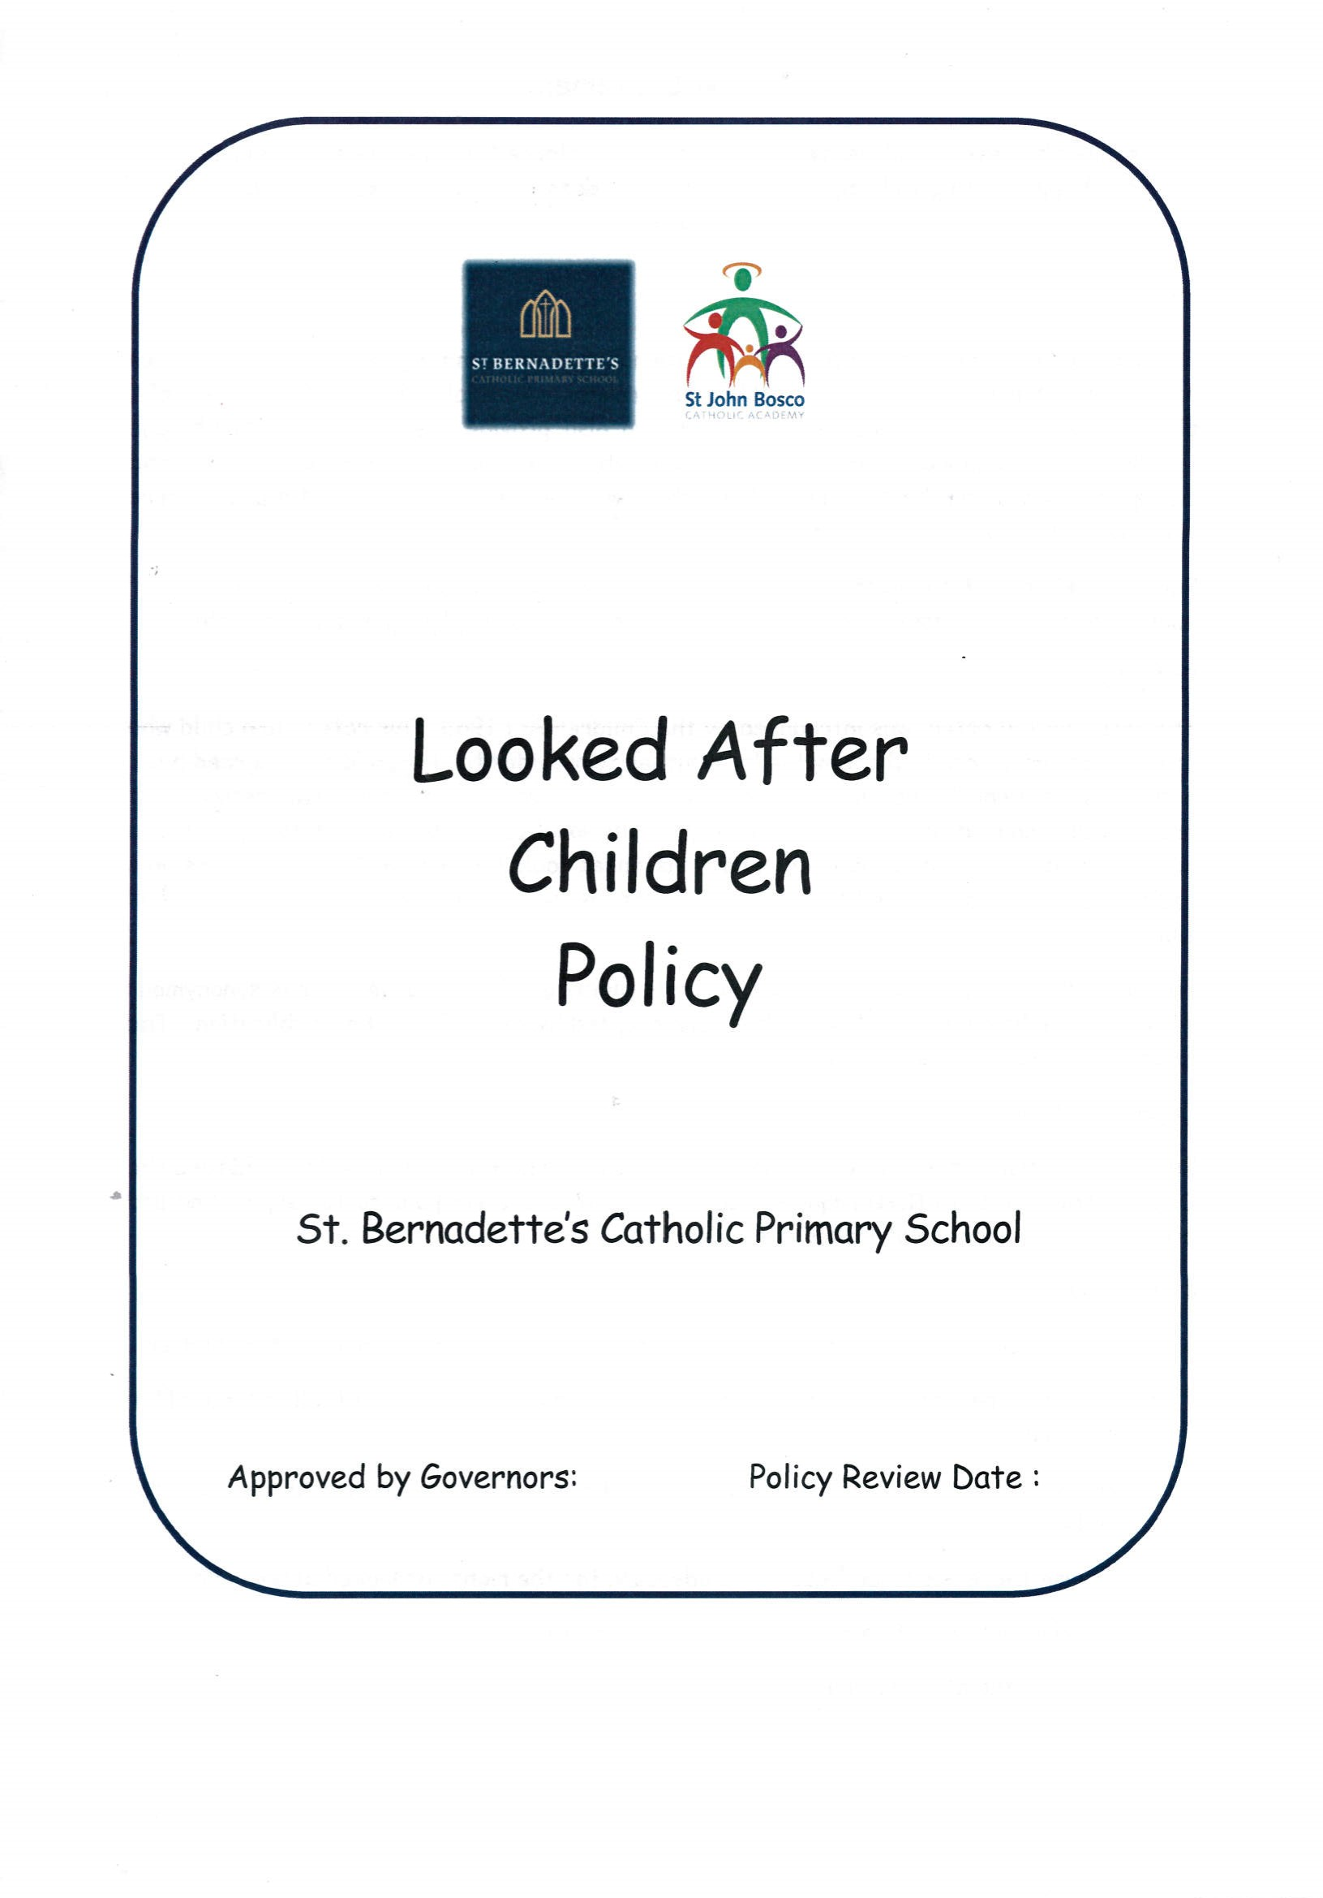




Mobile Phone

&

Smart Device

Policy

St. Bernadette’s Catholic Primary School

Approved by BoD: 26 March 2026
Policy Review Date: 26 March 2029

Approved by BoD:
Policy Review Date:

Policy Statement

St. Bernadette’s Catholic Primary School is a mobile-free school during the school day.

We recognise that mobile phones and smart devices present safeguarding, online safety and wellbeing risks, including:

- Exposure to inappropriate content
- Cyberbullying
- Unauthorised photography or recording
- Data protection breaches

In line with Keeping Children Safe in Education (KCSIE 2025/2026), we adopt a precautionary approach to minimise risk and ensure a safe learning environment for all pupils.

Aims

- To safeguard children from potential harm linked to mobile technology
- To promote safe, responsible and appropriate use of technology
- To ensure staff model safe and professional conduct
- To reduce disruption to teaching and learning

Scope

This policy applies to:

- All staff
- Pupils
- Parents/carers
- Visitors and volunteers

It applies to:

- Mobile phones
- Smartwatches with communication capability
- Tablets and personal smart devices
- Any device capable of taking images, recording or accessing the internet

Staff Use of Mobile Phones and Devices

During the School Day

- Personal mobile phones must be:
  - Switched off or on silent
  - Stored securely (e.g. staff lockers or designated areas) during teaching time

- Mobile phones must not be used in classrooms or in the presence of pupils, except in emergencies authorised by a Senior Leader.

Permitted Use

Staff may use mobile phones:

- In the staff room
- Off-site
- During breaks and lunchtime (away from pupils)

Communication with Parents and Pupils

In line with KCSIE 2025/2026 and staff conduct guidance:

- Staff must not:
  - Use personal phones to contact pupils or parents
  - Share personal phone numbers
  - Communicate via personal social media or messaging apps

- All communication must take place via:
  - School telephones
  - Official school systems and email accounts
Professional Conduct and Safeguarding

Staff must:

- Never send or receive inappropriate images or messages
- Never allow pupils to photograph or record them using personal devices
- Maintain professional boundaries at all times

If concerns arise regarding a staff member’s device:

- The concern must be reported immediately to the Designated Safeguarding Lead (DSL)
- The device must not be searched by staff unless authorised
- The matter will be managed in line with:

  - Child Protection procedures
  - Allegations against staff procedures
  - External agency advice (e.g. Police, LADO)

Use of Images and School Devices

- Only school-owned devices (e.g. iPads) must be used to take photographs of pupils

- Images must be:
  - Used inline with parent permissions on Arbor
  - Stored securely in line with GDPR and data protection requirements
  - Deleted when no longer required

- Staff must follow the school’s:
  - Data Protection Policy
  - Acceptable Use Policy
  - Online Safety Policy

School Events and Educational Visits

- Staff must not use personal mobile devices to take photographs of pupils

- Parents/carers:
  - May take photographs at public events (e.g. Sports Day) of their own children only
  - Must not photograph other children

- On school trips:

  - Only school devices (e.g. class iPads) must be used for recording images
  - Parent helpers must not use personal phones to take photos of pupils
  - Where necessary, school devices may be issued to support the visit

Visitors, Volunteers and Contractors

- Must not use mobile phones in areas where children are present

- May only use phones in:
  - Staff room
  - Designated areas
  - Off-site during breaks

- Must follow all safeguarding and visitor procedures

Pupil Use of Mobile Phones
General Expectations
St. Bernadette’s Catholic Primary School discourages pupils from bringing mobile phones to school.

When Phones Are Brought to School

Where necessary (e.g. independent travel):

- Phones must be:
  - Switched off
  - Handed to the Class Teacher on arrival/ Placed in the phone box

- Phones will be:
  - Stored securely
  - Returned at the end of the school day

The school accepts no liability for loss or damage.
Misuse of Mobile Phones

If a pupil is found using a mobile phone:

- The device will be confiscated
- Stored securely in the School Office
- Returned at the end of the day

Serious Misuse

Serious breaches include:

- Taking photos or videos of pupils or staff
- Sharing inappropriate content
- Cyberbullying

These will be treated as safeguarding and behaviour concerns and may result in:

- Sanctions in line with the Behaviour Policy
- Parental involvement
- Removal of permission to bring a phone to school
- Safeguarding referrals where necessary

Where images are taken:

- Pupils will be required to delete them in the presence of a Senior Leader
- Further action may be taken depending on severity

Cyberbullying and Online Safety

In line with KCSIE 2025/2026:

- The school recognises that mobile phones can be used to facilitate bullying

- Pupils are taught:
  - Safe communication
  - Respectful online behaviour
  - How to report concerns

Parents are encouraged to:

- Monitor children’s device use
- Support safe and appropriate use of messaging and social media

Communication with Parents

During the school day:

- Parents must contact the school via:
  - School Office telephone
  - School email

Pupils must not use mobile phones to contact parents during the school day.

Safeguarding and Monitoring

All concerns relating to mobile phone misuse must be:

- Reported to the DSL
- Recorded in line with safeguarding procedures

The school will respond in line with:

- Child Protection Policy
- Behaviour Policy
- Online Safety Policy

Roles and Responsibilities

Principal

- Overall implementation of the policy

Designated Safeguarding Leads (DSLs)

- Manages safeguarding concerns related to device use

Staff

- Model appropriate behaviour
- Enforce the policy consistently

Parents/Carers

- Support the school’s expectations
- Reinforce safe use at home

Monitoring and Review

This policy will be:

- Updated in line with national guidance
- Approved by the Governing Body

Conclusion

St. Bernadette’s Catholic Primary School is committed to maintaining a safe, focused and respectful learning environment. The controlled use of mobile technology is essential to safeguarding children and promoting their wellbeing in an increasingly digital world.

