Teaching and Learning Guidance

St. Bernadette’s Catholic Primary School

Approved by BoD: 18 June 2026
Policy Review Date: 18 June 2029

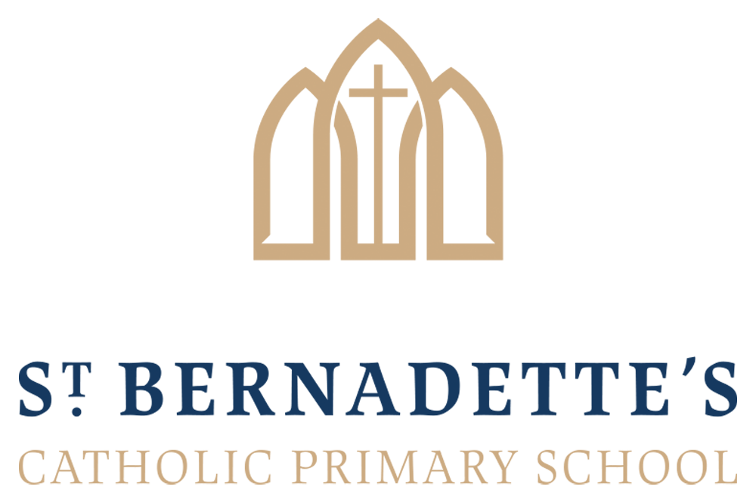

Mission Statement
To ensure that every child experiences a broad, balanced and relevant curriculum in a happy, caring school, which bases all it does on a committed Catholic Foundation.
At St. Bernadette’s we provide a caring, supportive and stimulating environment with high quality teaching through which to foster:
- Bible Teachings
- Gospel Virtues
- British Values
- Rights of the Child
- Characteristics of Effective Learning
- Citizenship

Our Aim

At St. Bernadette’s we strive to ensure our children will receive high quality learning opportunities which inspire, as well as develop and deepen understanding, knowledge and skills. The quality of teaching is central to high educational standards and achievement.
We expect every teacher to be a good teacher – no child deserves less.

Our Principles

Our teaching and learning guidance is a statement of our beliefs on:

• How children learn best
• What makes a great lesson?
• How learning environments support learning
• How planning and teaching supports learning
• How parents and carers support learning
• The role of Governors

We are constantly reviewing our practices according to the broad principles outlined in this guidance.

Children learn best when:

• They are safe, happy and confident to take risks
- They have opportunities to work independently and collaboratively
• Teaching is engaging, motivating and children are engaged in purposeful activities
• They understand what they are expected to do and what the final outcome should be
• Adults assist them appropriately
• They have high expectations of themselves and are challenged
• They are engaged in a variety of lower and higher order tasks including investigative activities that encourage enquiry and problem solving
• They are encouraged to reflect and plan ahead, building on their strengths and learning from their mistakes
• They are able to draw inspiration from others
• They are encouraged to see their learning as relevant to their everyday lives and futures
• They are supported from home
• There is a purposeful atmosphere, supported by the school’s behaviour systems

A great lesson is when:

• There is a ‘hook’ stimulus to engage the children in the learning
- Reference is made to previous and future learning
• A range of strategies are used to ensure participation by all children during whole class teaching
• There is clear, succinct modelling of how to achieve each of the success criteria
• There is concise, achievable success criteria that demonstrate how to meet the learning intention
• There is a range of inclusive and incisive questioning (refer to Questioning Guidance 2020)
• There is highly effective behaviour management (refer to Behaviour Policy)

Learning environments support learning when:

• They are tidy and organised with resources accessible and clearly labelled
• Displays are used to support and celebrate learning and are relevant to the children’s current learning
• Seating arrangements support collaborative and independent learning
• Daily routines are made explicit to children and embedded so that time is not wasted
• Children are encouraged to respect the school space and resources
- Maximum time will be given to teaching and learning

Planning and teaching supports learning when:

- Teachers use the school’s planning frameworks and documents
- Teachers develop and use robust subject knowledge to inform their planning and feedback
- Medium term planning is used effectively to structure the children’s learning and short term planning responds to Assessment for Learning
- Teachers use informal and formal assessment procedures to tailor their teaching to meet the needs of the children

- Teachers give regular feedback to children both verbally and through marking to consolidate and extend learning (refer to Marking Policy)
- Teachers give clear explanation and instructions
- Teaching is well paced, stimulating and enthusiastic
- Connections are made between different curriculum areas and within the same curriculum area
- Questioning is used effectively to assess learning and develop ideas (Questioning Policy)
- Children are given opportunities to talk about their learning and are taught directly how to collaborate
- High expectations are expected at all times
- Rich and varied learning opportunities are provided as well as fun, stimulating and memorable contexts for learning

Differentiation

So that we always have the highest possible expectations of individual learners and so they can demonstrate what they can do, understand and achieve, teachers will differentiate the curriculum according to individual needs by:

- pace;
- content;
- task;
- relevance;
- resources;
- extension;
- autonomy;
- outcome;
- teacher/adult support.

Differentiated tasks will be detailed in weekly planning. Learning objectives will be specified for all differentiated teaching and reference will be made in weekly plans to Individual Education Plans where appropriate.

Children with special educational needs (including gifted and talented children) receive support from Teaching Assistants. Additionally, advice is sought from relevant external support agencies when and where the need demands it. (See Special Educational Needs Policy)

Teachers set individual targets each term per child in English for reading and writing and for Mathematics. This is in addition to the formative assessment targets the teachers communicate to the children on a weekly or daily basis where appropriate.

At St. Bernadette’s we recognise the importance of key skills.

Opportunities will be made available across the curriculum to develop:

- application of number;
- communication;
- computing skills
- problem solving;
- working with others;
- improving own learning and performance.

Parents/Carers

The role of parents and carers parental involvement is fundamental to helping children to learn. Parents and carers have a responsibility to support their children and the school:

• Ensuring that their child arrives at school on time and has the best attendance record possible, which includes avoiding taking holidays during term-time
• Reading with and/or to their child regularly and ensure that home learning tasks are completed on time and to a good standard
• Attending parents’ evenings and striving to work positively in partnership with school staff
• Promoting a positive attitude towards school and learning in general by taking an active interest in the life of the school and their child’s learning journey
• Ensuring that their child is equipped for school with the correct uniform and PE kit
• Informing school if there are matters outside of school that are likely to affect a child’s performance or behaviour (refer to Home School Agreement)

The Role of Governors

Our Governors support, monitor and review the school’s approach to teaching and learning.

In particular they:

• Monitor the effectiveness of the school’s teaching and learning approaches through the school’s self-review processes, which include discussions with subject leaders, the head teacher’s report to governors and school visits
• Ensure that the school buildings and premises are used optimally to support teaching and learning and are compliant with health and safety regulations
• Seek to ensure that our staff development and our performance management promote good quality teaching
• Monitor how effective teaching and learning strategies are in terms of raising pupil attainment
• Ensure that staff appraisal is undertaken systematically and according to school policies
• Share their expertise and talents with the school

How is this Guidance Monitored?

• All staff are responsible for the effective implementation of this guidance.
• The guidance will be monitored through conversations with children and class teachers.
• Work will form an important part of the monitoring process, however, this will always be carried out alongside the children to allow them to provide vital input into the feedback process.

